Test Scanner:

sudo apt-get update

sudo apt-get install sane

sudo sane-find-scanner

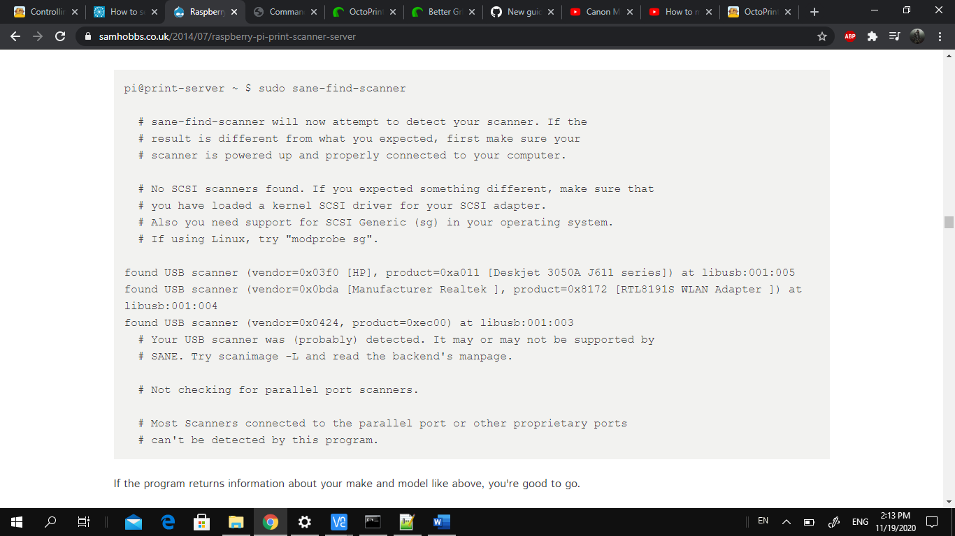

If the program returns information about your make and model like above, you're good to go.

Next, try the following:

sudo scanimage -L

You should get output like this:

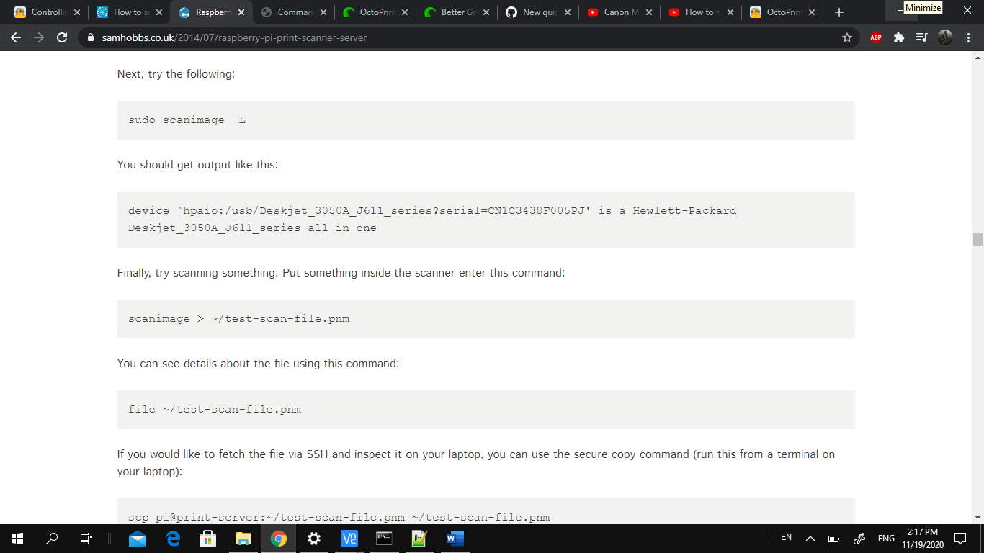

Finally, try scanning something. Put something inside the scanner enter this command:

scanimage > ~/test_scan.pnm

File will be saved in **/home/pi/** directory

open file in **imageviewer** of RPi to confirm the scan